OUTPUT:

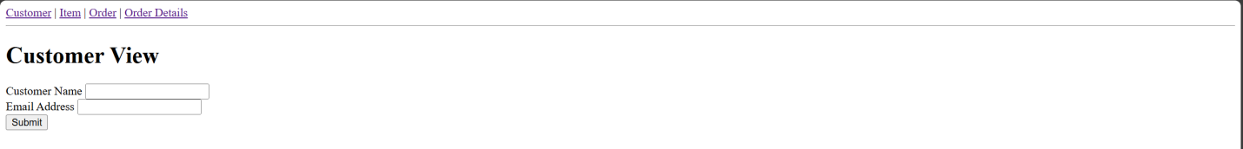

Codes:

ViewController.php

App.blade.php

Customer,home,item,order,orderDetails:

